Edith Elizabeth Appleton Diaries - Volume 2 (25 July 1915 to 25 April 1916)
April 1916
April 1st. Very foggy – yesterday – went for walk – bed – Patient doing well so far. We have such a charming cook for our Mess – He has fits & is very small – yesterday – I was asking him for a fried potato to take to eat before I went to bed - & as he turned round to say “yes” pulled the whole tin of gravy – for both lunches – off the stove on to the floor – about a gallon – all wasted. I was terribly sorry - & told him I would keep out of his way at meal times – so last night he said – “Aren’t you coming no more for a snack before you go to bed?” so I said “No” – Tonight – when I went to get my tray of things for the night – I found a wonderful – fancy cake – made for me – He was a pastry cook in peace time.
Fog horns have been hooting all night until about 1/2 an hour ago – now it is clear, must be 4 o’c. Ward is just changing.
April 1st:
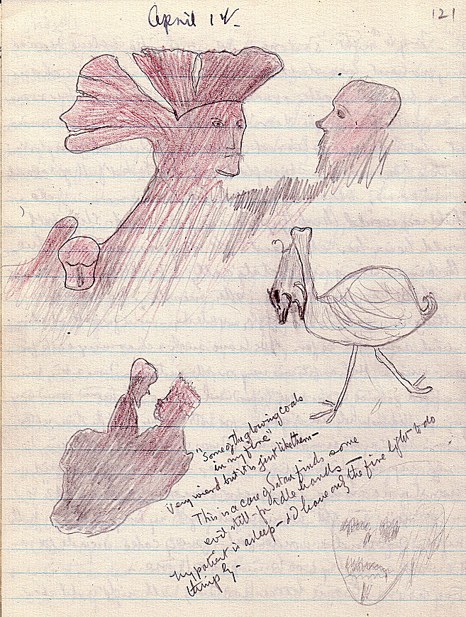
Some of the glowing coals in my fire”. Very weird but it is just like them –
This is a case of Satan finds some evil still – for idle hands –
My patient is asleep - & I have only the fire light to do things by.
[April] 2nd. I am looking after a sick V.A.D. tonight – an elderly woman – the image of Hartigan who has traveled & read - & lived – I have just been chatting to her. She is from No. 10 Rouen - & has been working in the German ward – because she speaks German. One of the men told her that they were giving themselves up to the English in big numbers in some places – but that the English wouldn’t take them, sent them back to their own lines – where they would be shot for desertion. Another told her – that before Christmas the Kaiser called up I forget how many men – but was not able to get nearly the full number – thank Goodness – perhaps they are running short at last. Yesterday was a perfect day – hotter than many summer days. I took a piece of cake – a cigarette & a book of poetry – (in case I fancied any of them) & went to the prettiest spot of the woods I love. It was an hour quick walk to get there – but once settled on a carefully selected spot – where I shouldn’t crush the daffs - & primroses – I just basked in the hot sunshine – fancied all three things cake – then cigarette (about the 5th since Nov.) & book - & listened to the hum of insects & the songs of birds, & reveled in the sun - & flowers & everything until I was nearly asleep then home & to bed. There were no human beings near – but millions of live things butterflies, bees – creeping things & birds – all busy with their day’s work - & taking not the least notice of me. All happy except a couple of silly ass blackbirds who were quarrelling over a bit of dirty looking stuff all the time.
4 o’c. Guard has just changed which means that 2 sleepy Frenchmen stagger out of the house which is open for the men on duty – about 2 mins before changing time. Two come up from their billets take over - & when the late guard are well away – the fresh ones – go into the house & to sleep! The little dog calls them if by unusual chance anyone should pass - then if he barks loud enough to call them one comes out & curses him & goes in again.
[April] 3rd. Think there must have been some spirit influence at work this morning that made me do a thing I hate doing & quite against my own will – but which gave me great pleasure – It was – I met the Ambulance train – started for a country walk as usual - & then hating every step - & the thought of the crowd - & strange sisters I should run against went straight to the station. I found that the two Sisters of the train were old friends of mine – one – was one of the 4 St. Bart’s I started the Campaign with – was with one at Chatham – on the Palm Branch (same cabin) No. 14 Gen. She only left there to join No. 19 train at the end of Jan – so she has had a less moveable time than mine – We had a great talk about old times from St. Barts onwards – I brought them both up to Matron – then out to coffee – then showed them over the hospital & bits of Étretat, then back to their train [at 1 a.m.].
I had given my camera up for lost - but Paterson has sent it to her own home to be kept for me! The Convoy was not a big one – chiefly wounded – some from poor old Robert’s hospital No. 18 C. C. S. at Lapugnoy. Miss Rentzsch donned red cuffs today denoting the rank of Matron. I began to feel like perpetual night nurse to the Sick Sisters – have another one to look after tonight – with an abscess in her ear – I know it is a most painful thing, but she was a bit hysterical about it. I gave her Asp & a good tot of Whiskey – after treating the ear – the last I heard of her was heavy snoring – whisky is good stuff. This is my NINTH night - & they said for a night or two.
Good news – a Zepp – has been brought down by the Thames. Mr. Boyd has left for 2nd Army – all are sorry to lose him.
3 a.m. I have just been promenading on the verandah - the shape & size of a ship’s bridge - It was pitch dark - except for stars - & the sea beating at my very feet made it seem like being on the Capt’s bridge at sea - & I wished I were.
[April] 4th. To think! I may be going on leave in 2 weeks or so - No news.
[April] 5th. [But written as 4th.] Do not feel inclined to write my diary - & anyway there is nothing to say. These blessed submarines are a nuisance! Havre harbour is closed again, & the two who went on leave yesterday - are still in Havre - it may affect all our leaves. Still on night duty. Thomas doing well - so far - Stitches taken out today. Saw the new moon - not through glass. Did not go for a walk yesterday morning - was too tired - tumbled into bed & slept soundly from 12 to 6.30 - with only waking once - delightful. No mail in - hope to Goodness - there have been no boats torpedoed. 4 a.m. The monotony of the night was relieved at 3 a.m. by the coming of the Night Super - to say that the Staff nurse in Casino 5 - fearfully heavy surgical ward - had fainted badly so we decided to tell Matron & have her brought along here where I could keep an eye on her - She is fixed now with hot bottles - Soda & Salvolatile - & the Night Super will be coming back in a few minutes to take a friendly plate of porridge with me. Poor Sheard had to be rudely awakened & sent on duty in place of Bell. the sick one.
Midnight, 6th & 7th. Nothing has happened at all exciting the last two days & I have not even been for a respectable walk. Felt tired for some reason & went to bed early. No sign of coming off night duty yet have done 12 1/3 nights now. Two submarines have been caught at Havre - & 1 at Folkestone. Our English patients who left today are held up at Havre - as the port is closed. Watson is hoping she will get off for leave tomorrow all right - & we 3 for next week are hoping we shall get off all right too.
Every morning at day break the crows amuse me very much. They come up in battallions of about 1000 each to over the cliff on the left - & they drill - & exercise & squawk for about 1/2 an hour - & then fly off again to their various feeding grounds - but they do everything exactly like one bird - swing round together, ascend - alight - It must be drilling.
Great consternation in the dovecote tonight because the CofE Padre - has called to see me - two days in succession - I did see him tonight - but if they had only known - it was only to talk about the chapel arrangements - & to get two photos of graves - for relatives of two of my men who died.
[April] 9th. ’Ad ’orrible day on the 7th - Went to Havre with Allen (Day off) - because she was alone - Hired the bootmaker’s car - & started off 10 a.m.
Got to Havre - saw a great congestion of shipping in the Harbour - held up for submarines, & the masts of a torpedoed vessel
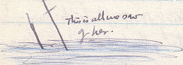
Then we did some shopping - & lunched - & went to the Galleries - where our car was to meet us - 1 p.m. no car - 1.30 - no car - 2 - the bootmaker bustled up in a heated condition to say the car has broken down & would not be repaired for 3 days. No cars to hire - no ambulances - no train to Étretat until 4.30 p.m. Went to H.Q., saw A.D.M.S. who told us a car was coming from Étretat to meet the mail boat (Smith returning from leave ). 3 o’c. Car came - 3.15 up strolled Smith - having been lunching since 1 in the Garden Tea Rooms. 3.30 - crept to the P.O. for mails - 3.40 - picked up a horrid young Y.M.C.A. man - who wanted a lift to Harfleur - “won’t be much out of your way” - only 10 kilometres. Left an old tyre to be mended - bought a new one - & at last left Havre - for Harfleur - dropped the young man - then on to Étretat & to bed at 4.30 - & had a little more than 1 hours sleep - before night duty. Made up my mind to get a sleep in the night. Fate said “No.” McBride - night Super - off with throat - I had to take her job - & am doing it again tonight - Matron said she knew I ought to be off night duty - & would take me off soon - I said I was pleased to fill a gap but had a horrible feeling of being in a web - of night duty - as if I never should get out - I have done 7 weeks this year already. Watson went on leave on the 8th - Am afraid I shan’t see Hilda - she will be on a walking tour when I have my 10 days leave.
[April] 10th. Night chiefly remarkable for having lost a sick officer. He was out at lock up time - & could be found nowhere - We reported it to the MO [CMO?]. - Major in Charge - & the Ward Master - no one could find him - Finally he turned up at 12.30 having lost his way in the country. Very glad he is back. Have put in for leave - & wonder if it will be granted - Letters from Mrs. Sharpe - Hilda - & one from Mother saying she is not well - hope she is much better now. McBride better - hope she will be fit to come on duty tonight.
[April] 12th. Came off night duty 10th, took charge of Thomas y’day - Raper had the day off - I am having it today - Thank you - have slept well and long and have just had breakfast in bed - intend to write letters, go through all my kit thoroughly - pack, read the Westminster, a book called Oud Bob [Owd Bob]- & a French book - Lunch in bed - (Madame will cook me something nice) - then get up & walk to Gonville [Gonneville] with Constable.
12 - 13 - 14 - Oh I do ‘ope it won’t be very rough. Hope you are better - hope to see you soon!
[April] 13th. To------morrow------. Enjoyed my day off yesterday very much it poured all day - & I turned out everything & repacked (sure sign of a move they say). In the afternoon I had Hilda Hindle & Constable in to tea & cards - we had a cosy toast & boiled eggs - honey & cake tea in the kitchen - did not go to a single meal in the mess room - had all over here. Stormy day.
Hope you are better. Matron got orders yesterday to take duty on the Asturias - don’t fancy she will care for a seagoing job - & there are no allowances on board ship!
[April] 14. All leave stopped - 10 Australians - sorry – Austr i lians - arrived.
[April] 17th. Palm Sunday yesterday. Went to Early & 11 o’c services - good sermon - church full. We heard a rumour last night of heavy fighting at La Bassée & Verdun - & that we had taken La Bassée. I am afraid the casualties will be terribly sad - whatever happened.
Yesterday an airship & a torpedoe destroyer were up & down to & fro, round & round - like a couple of terriers after a rat. The airship sighted the quarry later - & the steamer blew it up - crew & all complete - i.e. a German submarine.
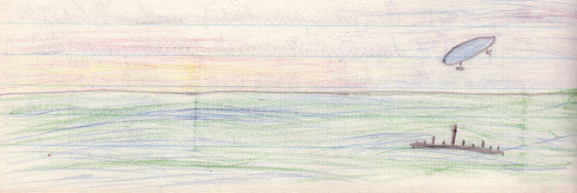
A letter from Hilda - she is in N. Wales.
[April] 18th. Marcey, Constable & I had half days – weather very heavy. Blowing 1/2 a gale with occasional gusts of rain or hail – We walked to Benouville - dug up a basket full of primrose roots – then went to the Inn for our usual boiled eggs & bread & butter tea – then went home – to the Cemetery - & tidied up 9 graves – took away all the dead flowers - & planted primroses – Col. Thackery, Capt Hammond – Kerr - & Sawden – came under my special care. If everybody does a few we may have them all tidy for Easter – the Cemetery is very beautifully kept.
[April] 19th. Raper & I saw Thomas off to England Went in, in professional style in a long convoy – at night our Ambulance carried 4 stretcher cases – Thomas, an officer & 2 Tommies – she stood the journey well – when we got there, the boat was not in – signals against her, some left her in charge of a Sister – screened off in a corner of the Officers hut. They were about full up - & very busy at Havre. The Padre went to see some Officers off – so we all rattled home together in one Ambulance – At about 12 midnight some New Zealanders – hailed our car & asked if we were going – anywhere in particular! Nice thing to ask at midnight. They wanted a hurt man taken somewhere – so we took him - & after that sprinted for Étretat at top speed – so fast that the pipes inside the car burnt holes in our rugs – we got back about 1:30.
[April] 22nd. Miserable wet weather – slight idea of leave starting after Easter. Dug primroses for the graves yesterday.
[April] 24th. Easter Day yesterday – we & I hope you all, had a very happy one. The three early services were packed with patients us & men of the Unit. I went to the 7 o’c. Morning service at the big church was very well attended - & evening service they were packed out. The Church looked very pretty, & Mr. Parry Evans gave a good sensible sermon – short – & one that appealed to the men. I did not go in the evening – went for a walk with Wilson - & landed at the church after the congregation had left - & I played & she sang – great joy – it is a dear little organ. We of La Plage clubbed together & gave our 100 men fruit salad & whipped cream for tea – they all enjoyed it very much indeed – much better than the sticky cakes one buys here – besides I have finished with the woman at the cake shop – she would not sell cake cheaper than 2 francs each for things the size round of a breakfast cup – for our men at Xmas time – so I didn’t buy them there - & never have spent a penny in her shop since.
This creature was out scouting yesterday – shiny dark grey – big one – no steamers in attendance.
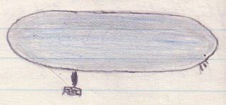
[April] 25th. We have been called for early bkfst – so I must be quick – A convoy came in about an hour ago. They called some people to go & help receive it. I started scratching my head yesterday – to think about equipping the new theatre that is to be in my charge – along with the two hernia wards - & ended by giving the Dispenser a list a yard long – of things to be getting ready for me. I have had my staff nurse changed three times since I took on this job – it will be quite useful to know – which one is to be the right one. It is a glorious morning – of sunshine - & fishing boats – sea dead calm rumour of leave starting – which does not excite me – because in the next breath it will probably be stopped again – now I must get up.
Volume Two ends here.

